Assignment # 04: Library Management System

Objective:
- Create a menu-driven Python program that allows a librarian to manage books in a library.
- Develop logical thinking.
- The program should allow the user to add books, view all books, search for a book, update book details, delete books, issue books, and return books.
__________________________________________________________________________________________________________________
Instructions:
- When the program starts, it should display a menu similar to this:
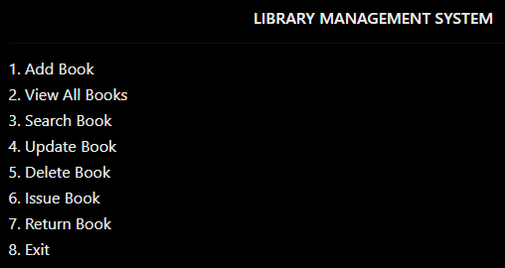
The user should select an option by entering a number. After completing that operation, the program should display the menu again until the user chooses Exit.
- Each book should have the following information:
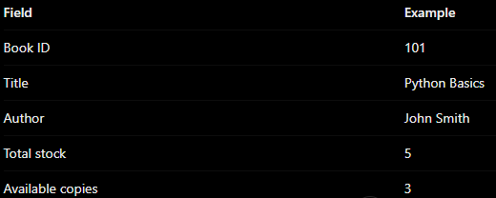
Use a dictionary to represent one book and a list to store multiple books.
__________________________________________________________________________________________________________________
Feature 1 — Add Book
- Ask for the book ID, title, author, and number of copies.
- Create a dictionary for the new book.
- Add it to the books list.
- Display a success message.
Challenge: Do not allow duplicate book IDs.
Feature 2 — View All Books
- Check whether the list contains any books.
- If empty, display “No books available.”
- Otherwise, use a for loop to display every book's details.
Feature 3 — Search Book
- Ask the user for a book ID.
- Search through the list using a for loop.
- If the ID matches, display the book's details.
- Otherwise, display “Book not found.”
Feature 4 — Update Book
- Ask for the ID of the book to update.
- Find the matching book.
- Ask for the new title, author, or copy count.
- Update the selected dictionary.
- Display a confirmation message.
Feature 5 — Delete Book
- Ask for the book ID.
- Find the book in the list.
- Remove the matching record.
- If it does not exist, display an appropriate message.
Feature 6 — Issue Book
- Ask for the book ID.
- Find the book.
- Check whether copies are available.
- If available, decrease the copy count by one.
- If no copies remain, display “Book is not available.”

Feature 7 — Return Book
- Ask for the book ID.
- Find the book.
- Increase its available copy count by one.
- Display a success message.
Challenge: Prevent returns from increasing stock beyond the number of copies the library owns. For accurate tracking, record issued books or loans.

